MEMORANDUM

To: Zoning Board of Adjustments
From: April Limburg, Planner
Date: April 27, 2021
Re: Appeal Case No. 40

INTRODUCTION: A request filed by Carver Construction on behalf of Bob Koening to allow for the construction of a 30’x36’ garage on the second lot of the property at 2014 W Fulliam Ave.

BACKGROUND: Carver Construction has submitted a request on behalf of Bob Koening to build a garage at 2014 W Fulliam Ave on the second lot towards the rear of the property. The property is 16,391 square feet. The property currently has a 828 square foot attached garage along with a 192 sq. ft. shed. The total square footage of accessory buildings on the property is 1,020. The owner would like to build a garage consisting of 1,080 square feet. The dimensions of the garage are 30x36. The proposed garage would cause the property to exceed the 1,440 maximum cumulative square footage of all accessory buildings and attached garages allowed by Section 10-20-2 (A) of City Code by 660 square feet.

The shed and items next to the proposed garage will be relocated, inside the new garage. There will be a 25’ driveway to enter the building. The garage will be used for storing a pontoon and other vehicles.

The property is at the corner of W Fulliam and Timberline Dr.

Attached is the application, site plan, and aerial of the property.

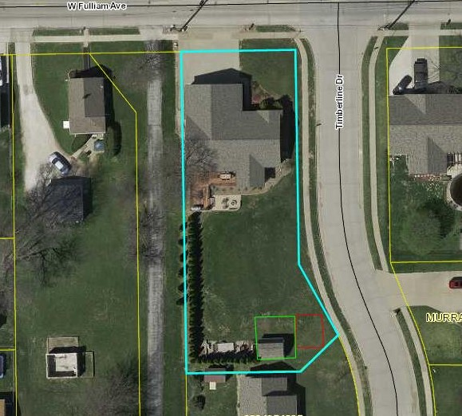
2014 W Fulliam Ave
30’x36’ garage
25’ concrete pad
30’x36’ Garage
25’ concrete pad

